CSIT314 Software Development Methodologies - Group Project

Sprint 3 - US41: Create IDP category
Interior Design Platform - Platform Manager
All diagrams were drawn in draw.io. Open "US41 Create IDP category.drawio" in this folder to edit them - each diagram is its own page in that file. The exported images are in the "diagrams" folder.

Assumptions
- The system is the Interior Design Platform from the project specification. Sprint 3 adds the Platform Manager's stories (log out and IDP categories, US40 - US45) and the Interior Designer's first IDP story (add a current IDP, US20).
- We follow B-C-E: the actor only talks to the boundary (page), the boundary only talks to the controller, and the controller works with the entity classes. There is one controller per use case.
- Following the lecturer's feedback (the same way Sprint 1 and 2 were changed): the boundary trims and checks all the input, the controller just calls the entity and returns the result (no canXxx() access methods), the entity does the duplicate / still-Active checks, an entity object is passed around instead of a dict, and each B-C-E diagram has only one entity.
- Being logged in as a Platform Manager (UC39) is the precondition of these use cases, so the pages and the B-C-E / sequence diagrams don't check the manager again (no PlatformManagerLoginController). managerLoginRequired in app.py only sends someone with no session to /manager/login.
- An IDP category groups similar interior design projects (IDPs), e.g. Living Room or Kitchen. It has a name, an optional description and a status (Active or Suspended).
- The category name is required, 3-50 characters, and must be unique. The page trims spaces around it and the entity ignores capitals ("kITCHEN " is the same as "Kitchen"). The description is optional, up to 500 characters.
- A new category always starts Active, so designers can choose it straight away when they add an IDP (US20).
- The IDP Categories list page is the US45 search page, the same way the User Profiles list is the US7 page.
- database/seedIDPCategoryData.py adds six demo categories (Living Room, Kitchen, Bedroom, Bathroom, Home Office, Commercial).

1. User story
Story ID | US41
User story | As a platform manager, I want to create an IDP category so that similar interior design IDPs can be grouped together.
Actor | Platform Manager
Priority | High
Story points (estimate) | 3
Acceptance criteria | 1. Given I am on the IDP Categories page, there is a "+ Create IDP category" button that opens an empty form.  2. The form has a category name (required) and a description (optional).  3. Given I enter a valid, unused name and click "Create", then the category is saved as Active, I go back to the list and see "IDP category created successfully".  4. Given the name is shorter than 3 or longer than 50 characters, or the description is longer than 500, then I see "Please fix the highlighted fields", what I typed is kept and nothing is saved.  5. Given another category already has the name (ignoring capitals), then I see "An IDP category with this name already exists" and nothing is saved.  6. Given I click "Cancel", then I go back to the list and nothing is saved.
Tasks | T41.1 Write the use case description and draw the use case diagram  T41.2 Draw the B-C-E class diagram and the sequence diagram  T41.3 Draw the wireframes for the list, the form, the form errors and the success message  T41.4 Add the idp_category table to database/schema.sql  T41.5 Write the unit tests first (TDD) for IDPCategory, CreateIDPCategoryController and CreateIDPCategoryPage  T41.6 Code IDPCategory.isCategoryNameTaken() and createIDPCategory() (duplicate check in the entity)  T41.7 Code CreateIDPCategoryController (just calls create)  T41.8 Code CreateIDPCategoryPage, platformManagerBase.html and the create form  T41.9 Write database/seedIDPCategoryData.py for the demo categories  T41.10 Run the test cases, fix bugs and push to the repo so the CI pipeline runs the unit tests

2. Use case diagram
The user story becomes one use case, UC41 Create IDP category. The Platform Manager is the only actor.
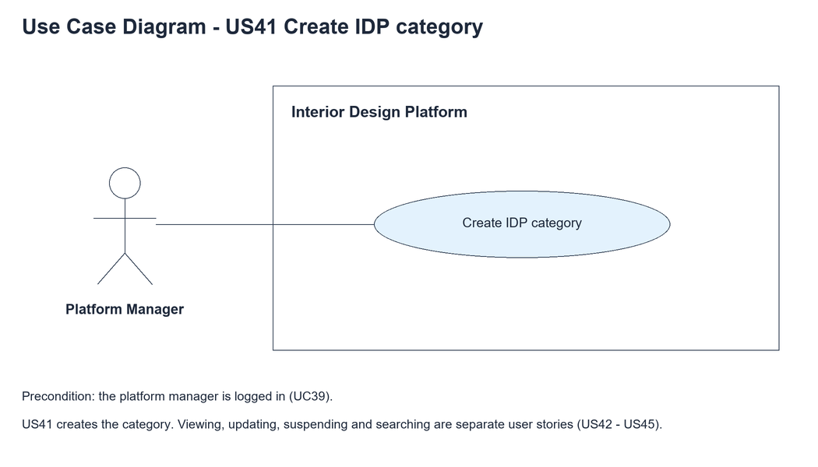
Figure 1: Use case diagram for US41 Create IDP category

3. Use case description
Use case | UC41 Create IDP category
Actor | Platform Manager
Brief description | The Platform Manager creates a new IDP category so similar IDPs can be grouped together.
User story | US41: As a platform manager, I want to create an IDP category so that similar interior design IDPs can be grouped together.
Preconditions | The Platform Manager is logged in (UC39).
Trigger | The Platform Manager clicks "+ Create IDP category" on the IDP Categories page.
Basic flow | 1. The Platform Manager clicks "+ Create IDP category".  2. The system shows the empty form.  3. The Platform Manager enters the category name and an optional description and clicks "Create".  4. The system checks the fields (name 3-50 characters, description up to 500).  5. The system checks that no other category has the same name.  6. The system saves the category as Active.  7. The system shows the IDP Categories list with "IDP category created successfully".
Alternative flows | 3a. The Platform Manager clicks "Cancel": the system goes back to the list and nothing is saved.  4a. A field is wrong: the system shows "Please fix the highlighted fields", highlights the wrong field and keeps what was typed. Back to step 3.  5a. The name is already used: the system shows "An IDP category with this name already exists" and keeps what was typed. Back to step 3.
Postconditions | A new Active IDP category is saved and listed.  Designers can now choose it when they add an IDP (US20).

4. Wireframes
The wireframes were drawn in draw.io. They are low-fidelity: they show the layout and the flow, not the final colours. The orange numbers match the notes under each screen.

4a - Create button
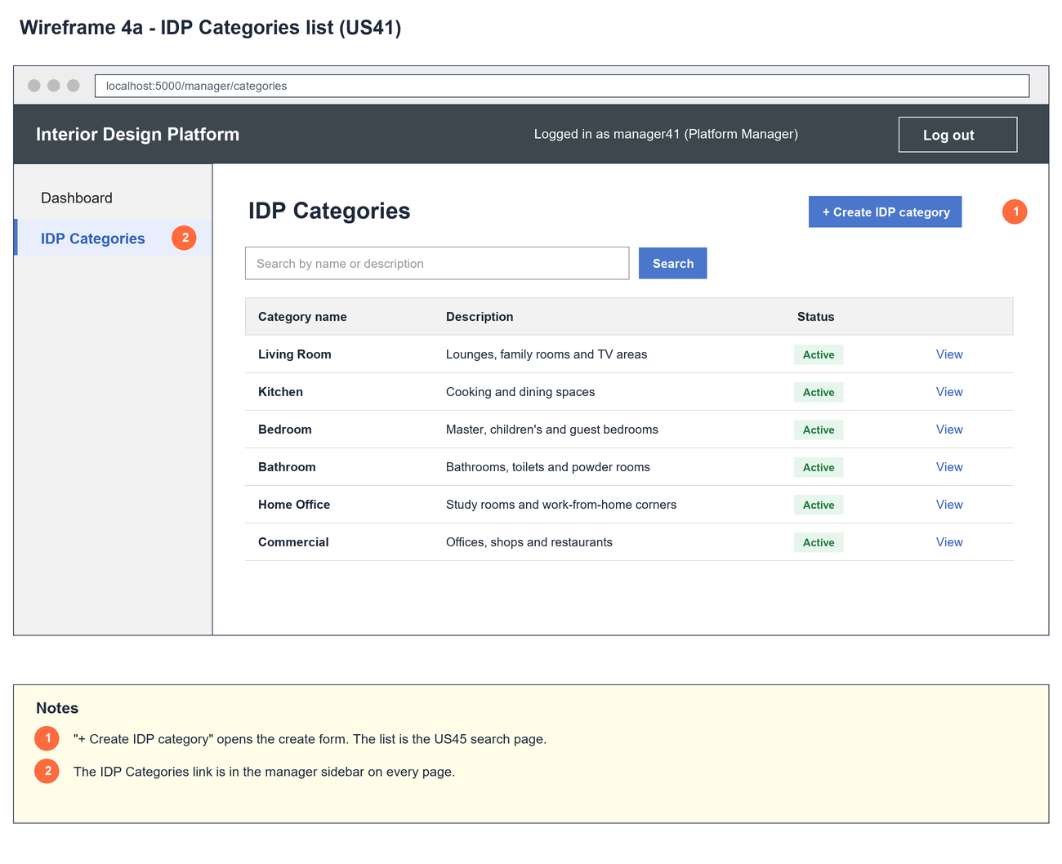
Figure 2: Wireframe 4a - Create button (US41)

4b - Create form
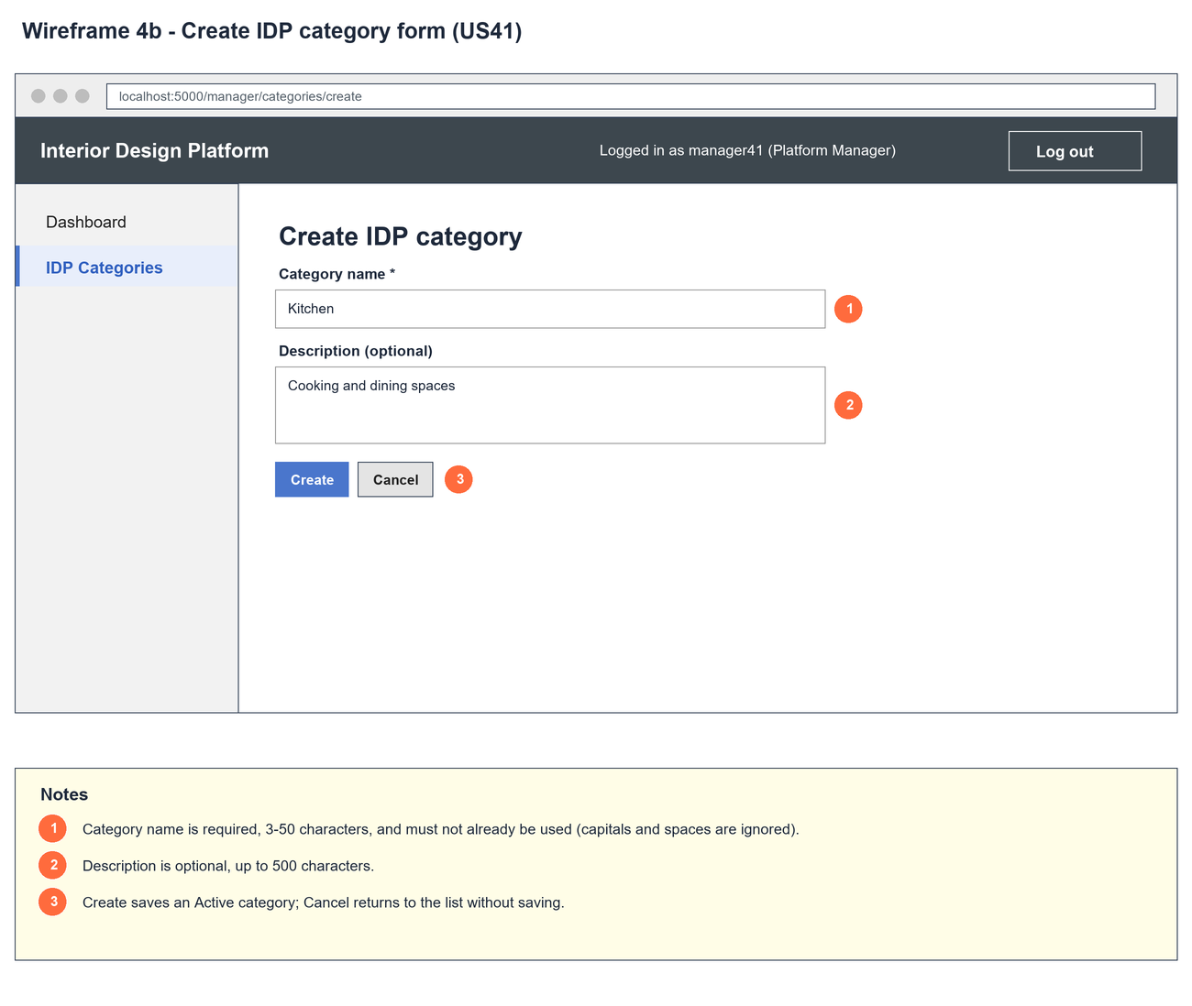
Figure 3: Wireframe 4b - Create form (US41)

4c - Form errors
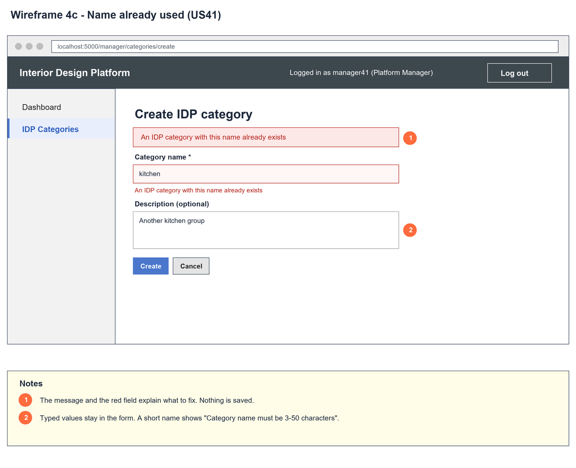
Figure 4: Wireframe 4c - Form errors (US41)

4d - Category created
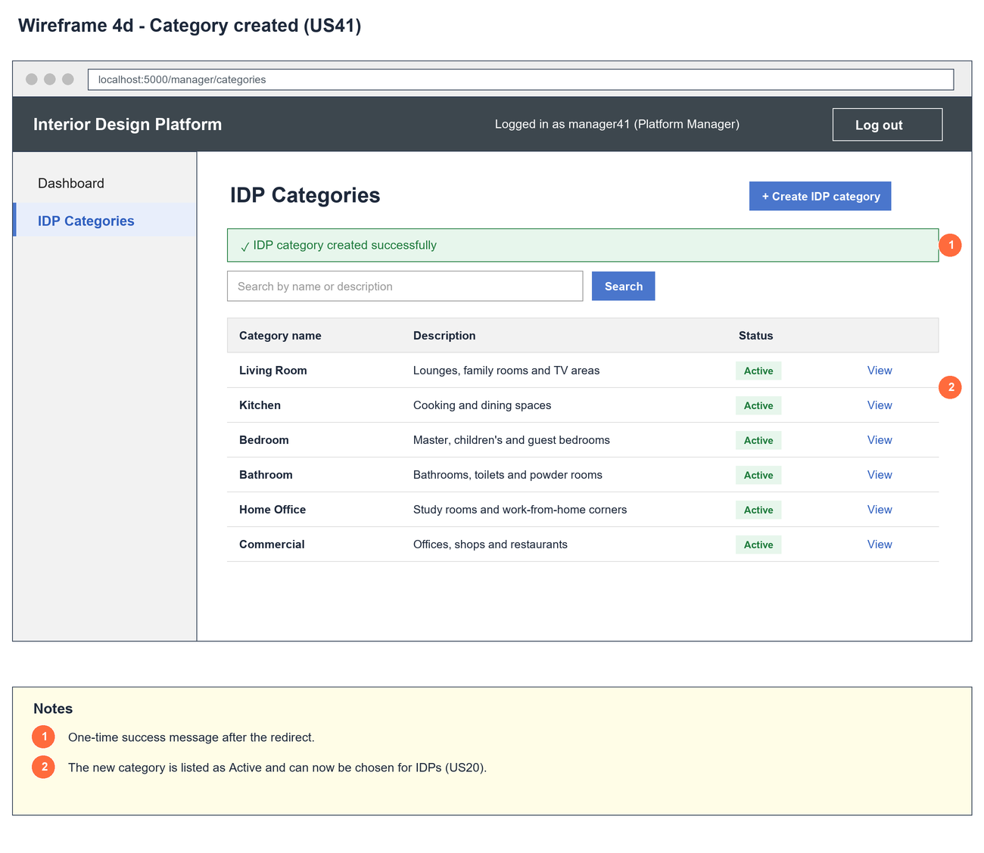
Figure 5: Wireframe 4d - Category created (US41)

5. B-C-E class diagram
The solid line means the boundary calls the controller. The dashed lines mean the controller uses the other classes. Only the operations needed for this use case are shown, with the same names as the code.
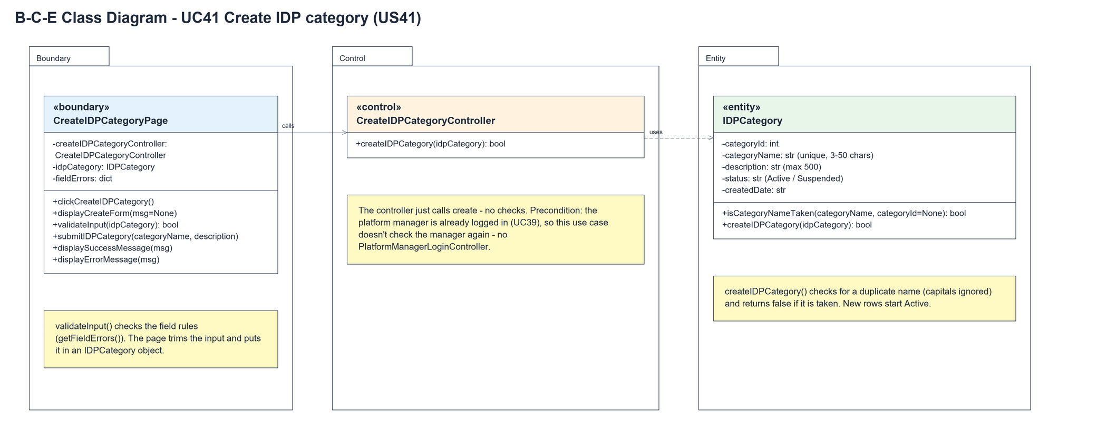
Figure 6: B-C-E class diagram for US41 Create IDP category
Layer | Class | What it does
Boundary | CreateIDPCategoryPage | The create form. submitIDPCategory() trims the input and puts it in an IDPCategory object, validateInput() checks the field lengths (getFieldErrors()), then the page calls the controller and shows the success or error message.
Control | CreateIDPCategoryController | Controller for UC41. createIDPCategory(idpCategory) just calls the entity and returns the result - no checks.
Entity | IDPCategory | One row of idp_category. createIDPCategory() checks for a duplicate name with isCategoryNameTaken() (capitals ignored) and saves a new Active row.

6. Sequence diagram
The sequence diagram follows UC41. On submit the page puts the input in an IDPCategory and validates it. The outer alt is valid or invalid input. When it is valid the controller just calls the entity, which checks the name isn't taken before saving. The inner alt shows the success redirect or the "name already exists" error.
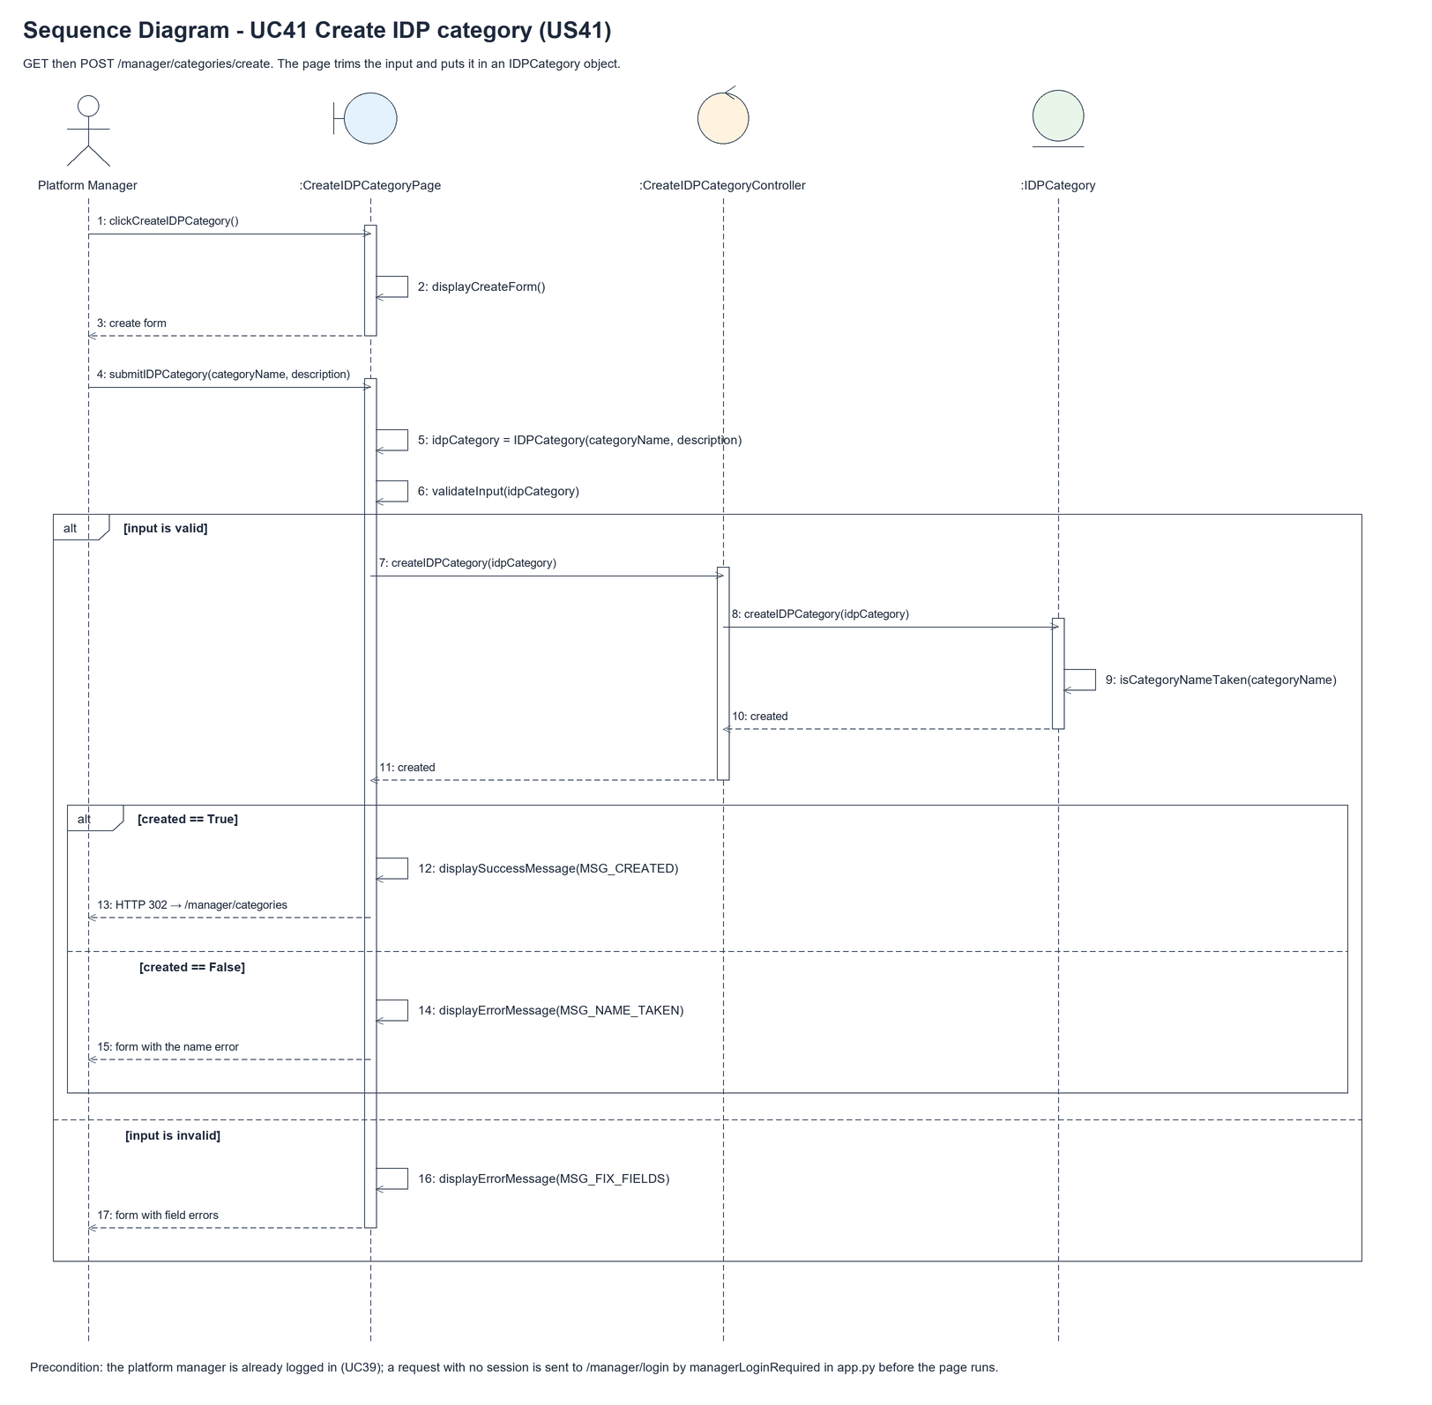
Figure 7: Sequence diagram for UC41 Create IDP category

7. Test cases
Test data used below (same as database/seedData.py and the test files): user profiles User Admin (id 1), Interior Designer (id 2), Customer (id 3) and Platform Manager (id 4), all Active. User accounts admin01 / Admin@123 (User Admin) and cust001 / Cust@123 (Customer). The manager account manager41 / Manager@123 (Daniel Tan, Platform Manager profile) is made first with UC8. IDP categories are made in each test with UC41, e.g. Kitchen ("Cooking and dining spaces"), Bedroom and Office.

7a. System test cases (black box)
Equivalence partitioning and boundary value analysis were used to pick the test data. Fill in "Actual result" and "Pass/Fail" after running each test.
Test ID | Scenario | Prerequisites | Test steps | Test data | Expected result | Actual result | Pass / Fail
TC41.1 | Create a category | Logged in as manager41. | 1. Open IDP Categories  2. Click "+ Create IDP category"  3. Enter the data  4. Click "Create" | Kitchen / Kitchen renovations | IDP Categories list with "IDP category created successfully". Kitchen is listed as Active.
TC41.2 | Description is optional | Logged in as manager41. | 1. Enter only a name  2. Click "Create" | Bathroom / (empty) | Saved and listed as Active.
TC41.3 | Name already used | Kitchen exists. | 1. Enter the data  2. Click "Create" | kitchen / Typed text | "An IDP category with this name already exists". The typed text is kept. Nothing saved.
TC41.4 | Name too short (boundary) | Logged in as manager41. | 1. Enter the name  2. Click "Create" | "Ki" (2 chars) | "Please fix the highlighted fields" and "Category name must be 3-50 characters".
TC41.5 | Name at the limits (boundary) | Logged in as manager41. | 1. Create with each name | "Kit" (3 chars), 50-char name | Both are saved.
TC41.6 | Description too long (boundary) | Logged in as manager41. | 1. Enter the data  2. Click "Create" | Kitchen / 501 chars | "Description must be 500 characters or fewer". Nothing saved.
TC41.7 | Cancel | Logged in as manager41. | 1. Open the form  2. Type a name  3. Click "Cancel" | Kitchen | Back on the list. Nothing saved.
TC41.8 | Not logged in | Not logged in. | 1. Open /manager/categories/create | - | The manager login page is shown.

7b. Unit test cases (for TDD)
These are written before the code (test-driven development) and run with pytest. They cover normal inputs, abnormal inputs and boundary values. Each one matches a test function in tests/test_us41_createIDPCategory.py (UT41.n = test_ut41_n_...).
Test ID | Class and method | Input / setup | Expected output | Type | Pass / Fail
UT41.1 | IDPCategory.createIDPCategory() | Kitchen / Kitchen renovations | Returns true. Saved as Active | Normal | Pass
UT41.2 | IDPCategory.isCategoryNameTaken() | "Kitchen", no categories | Returns false | Normal | Pass
UT41.3 | IDPCategory.isCategoryNameTaken() | "Kitchen", Kitchen exists | Returns true | Normal | Pass
UT41.4 | IDPCategory.isCategoryNameTaken() | "kITCHEN", Kitchen exists | Returns true | Boundary | Pass
UT41.5 | CreateIDPCategoryController.createIDPCategory() | Living Room / Lounges | Returns true. 1 category | Normal | Pass
UT41.6 | CreateIDPCategoryController.createIDPCategory() | "living room" after Living Room | Returns false. Still 1 category | Abnormal | Pass
UT41.8 | CreateIDPCategoryController.createIDPCategory() | Bathroom / empty description | Returns true | Boundary | Pass
UT41.9 | CreateIDPCategoryPage.validateInput() | Kitchen / Kitchen renovations | Returns true | Normal | Pass
UT41.10 | CreateIDPCategoryPage.validateInput() | "Ki" (2 chars) | False. "Category name must be 3-50 characters" | Boundary | Pass
UT41.11 | CreateIDPCategoryPage.validateInput() | 51-character name | False. categoryName error | Boundary | Pass
UT41.12 | CreateIDPCategoryPage.validateInput() | 501-character description | False. "Description must be 500 characters or fewer" | Boundary | Pass
UT41.7 | CreateIDPCategoryPage.validateInput() | Empty name | False. categoryName error | Abnormal | Pass
UT41.13 | /manager/categories/create (managerLoginRequired) | Not logged in, GET the form | Redirects to /manager/login | Abnormal | Pass
UT41.15 | CreateIDPCategoryPage.clickCreateIDPCategory() | manager41, GET the form | Form with categoryName and description | Normal | Pass
UT41.16 | CreateIDPCategoryPage.submitIDPCategory() | Valid data | Redirect to the list with "IDP category created successfully" | Normal | Pass
UT41.17 | CreateIDPCategoryPage.submitIDPCategory() | "kitchen" when Kitchen exists | "An IDP category with this name already exists". Typed text kept | Abnormal | Pass
UT41.18 | CreateIDPCategoryPage.submitIDPCategory() | Name "K" | "Please fix the highlighted fields". Nothing saved | Abnormal | Pass
UT41.14 | CreateIDPCategoryPage.submitIDPCategory() | " Kitchen " / " Cooking " | Saved as "Kitchen" / "Cooking" | Boundary | Pass

